**Git hub links for the projects -**

**For terraform -** [**https://github.com/karthikeyanrajan/devops-hackathon.git**](https://github.com/karthikeyanrajan/devops-hackathon.git)

**For Jenkins -** [**https://github.com/karthikeyanrajan/Hackathon-Application.git**](https://github.com/karthikeyanrajan/Hackathon-Application.git)

**For Infrastructure as Code (IaC):**

**Created AMI host machine With preinstalled docker and jenkins**



With that creating the Hostmachine and the same amiid is mentioned on the terraform variable to launch the instances

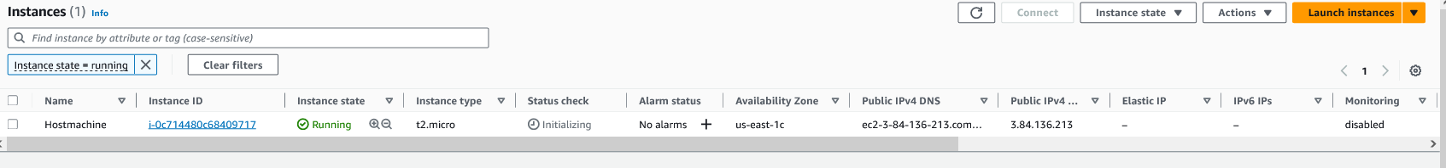

Cloning the terraform code git hub link and creating the AWS Infrastructure

git clone <https://github.com/karthikeyanrajan/devops-hackathon.git>

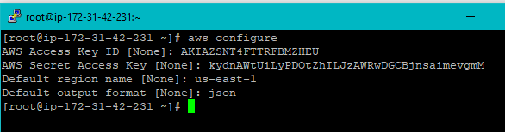

Configured aws cli

By using terraform codes created the AWS infra

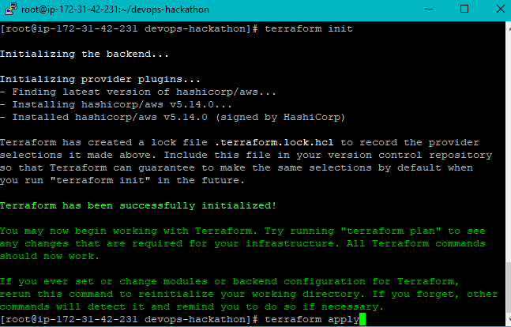

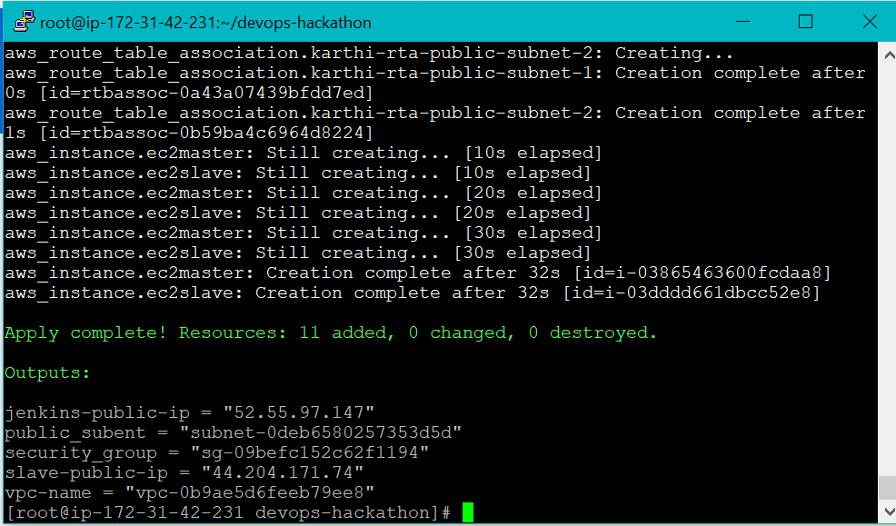

Two machines created with the names master and slave instancce vpc , subnet , igw,sg,routetable

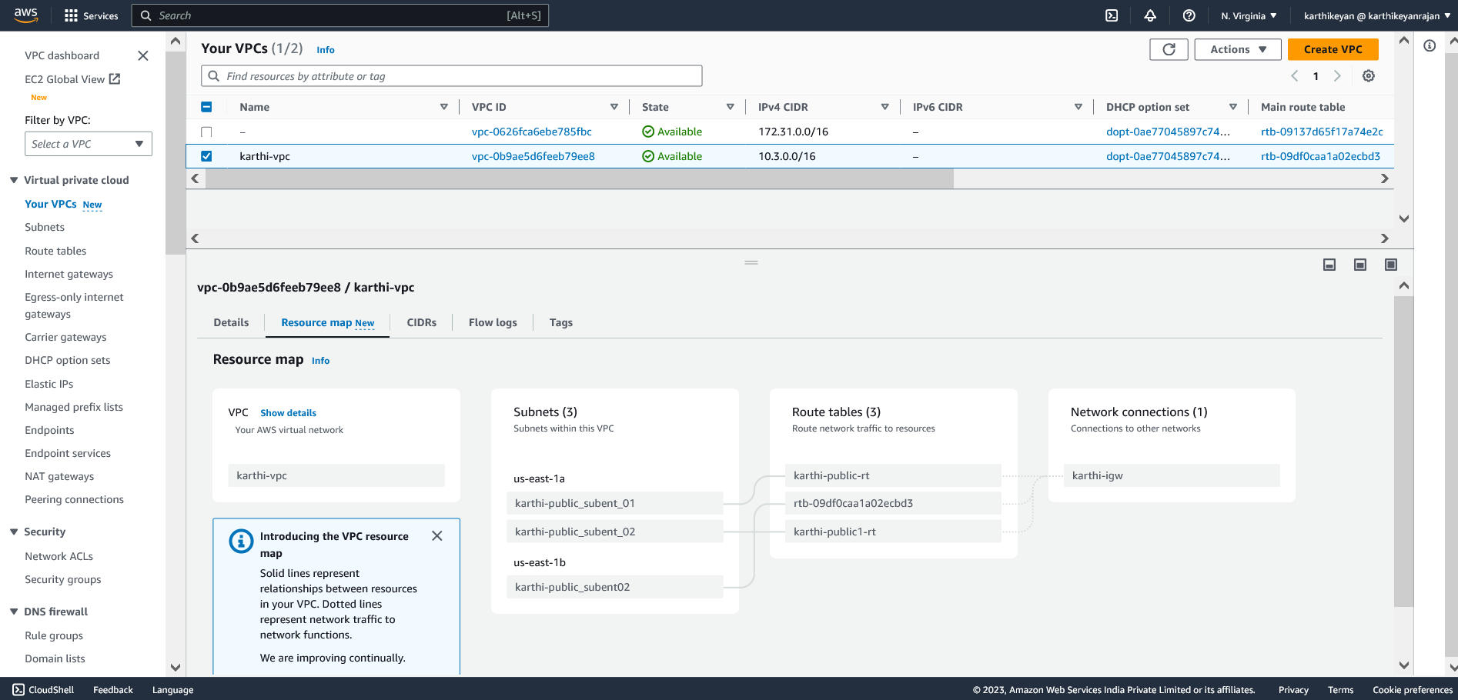

Subnet

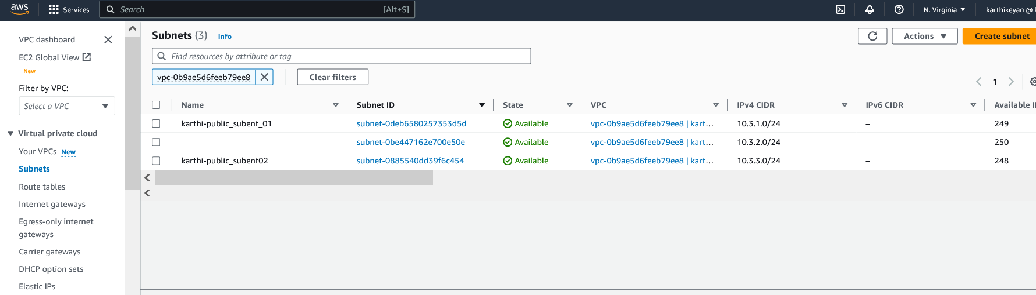

Igw

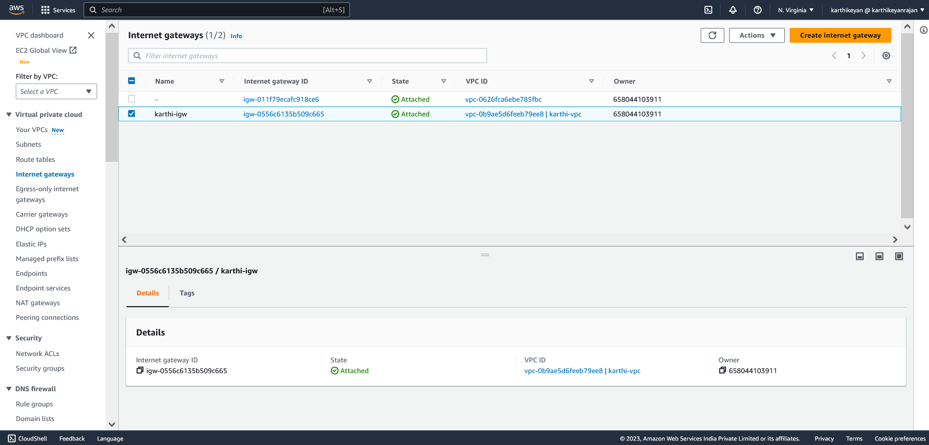

Routetable

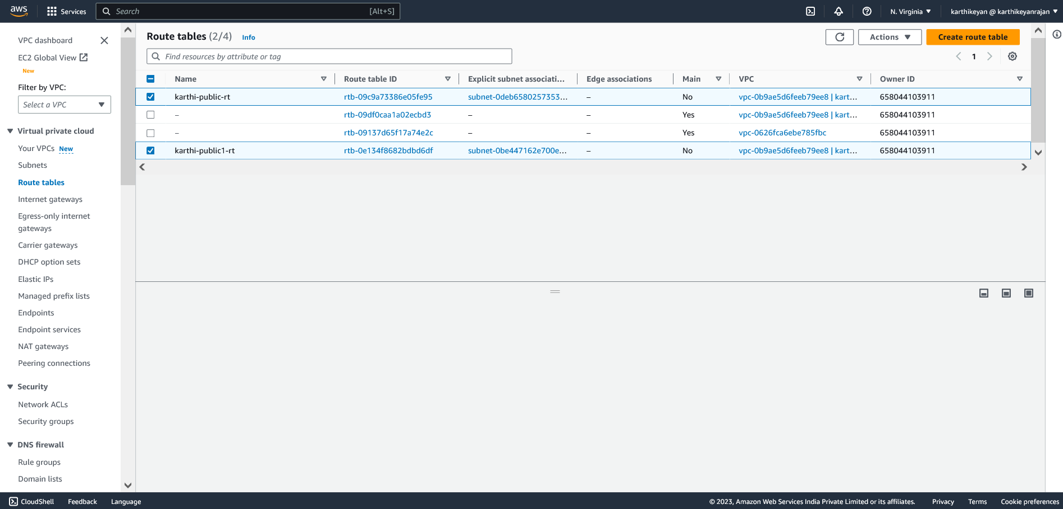

ALB:

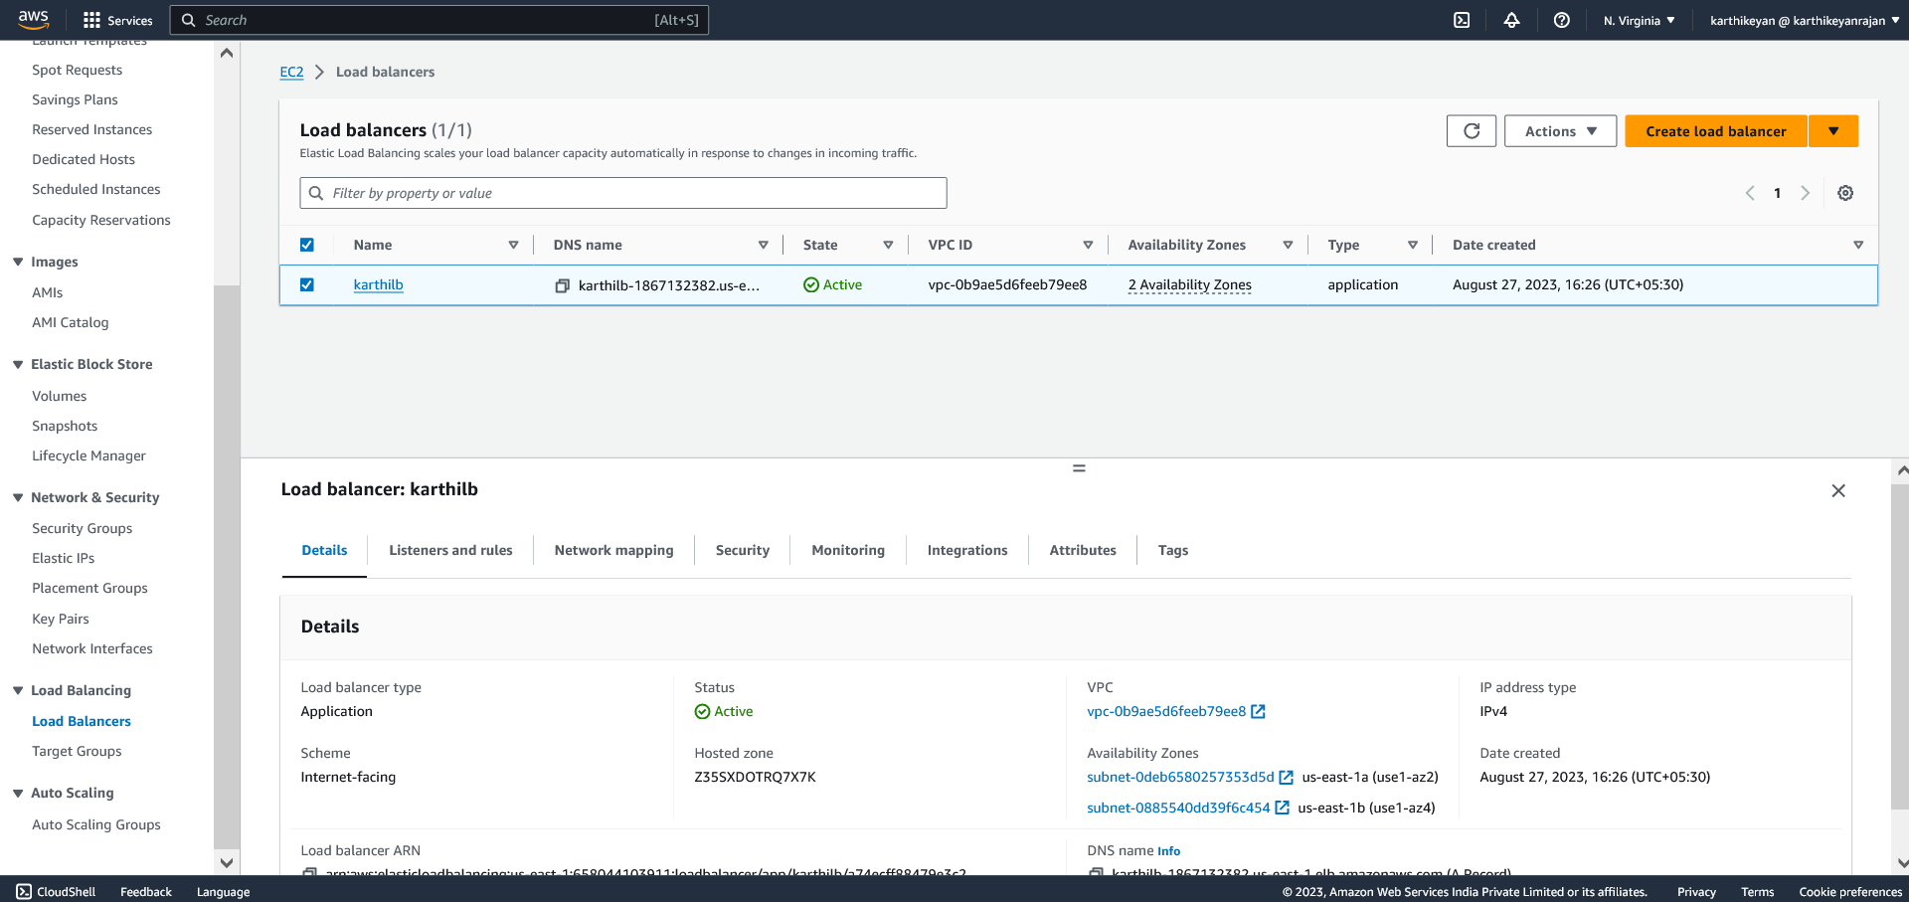

TARGET GROUP

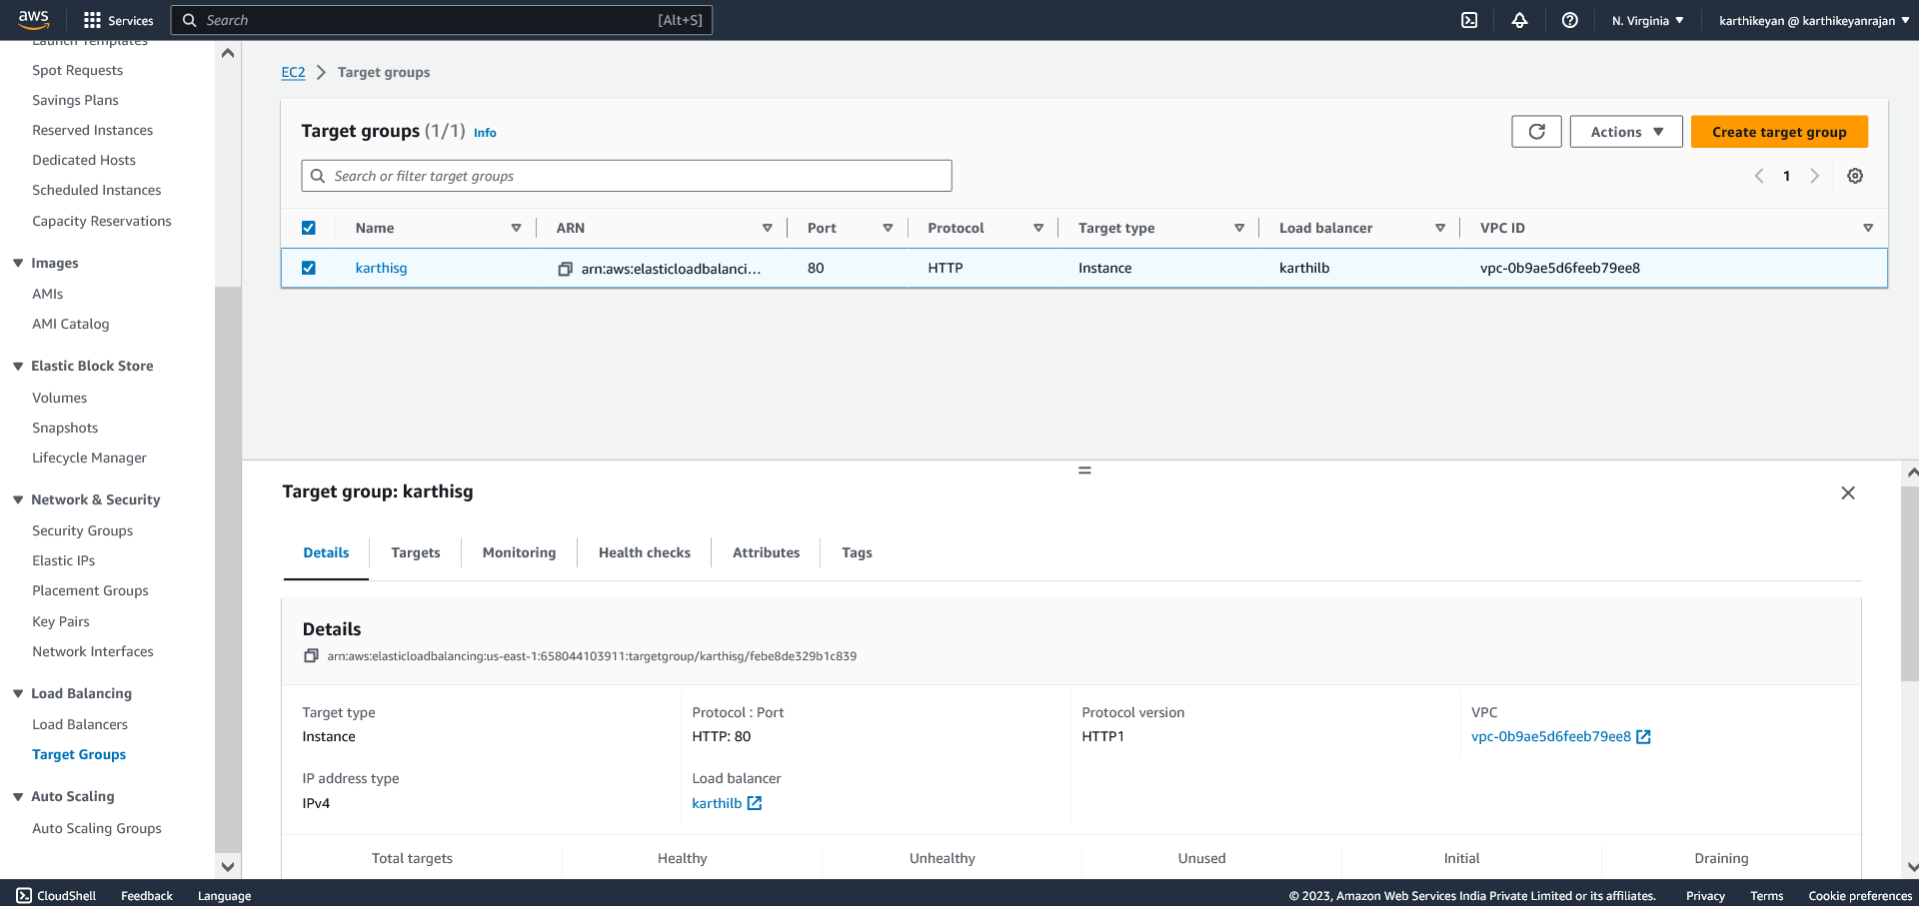

DNS - karthilb-1867132382.us-east-1.elb.amazonaws.com

Security group

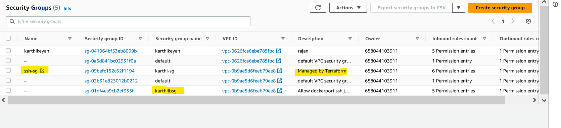

Keypairs

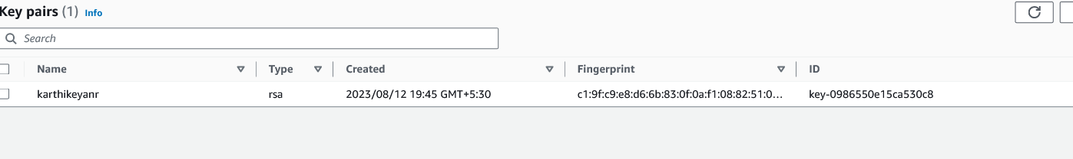

ASG

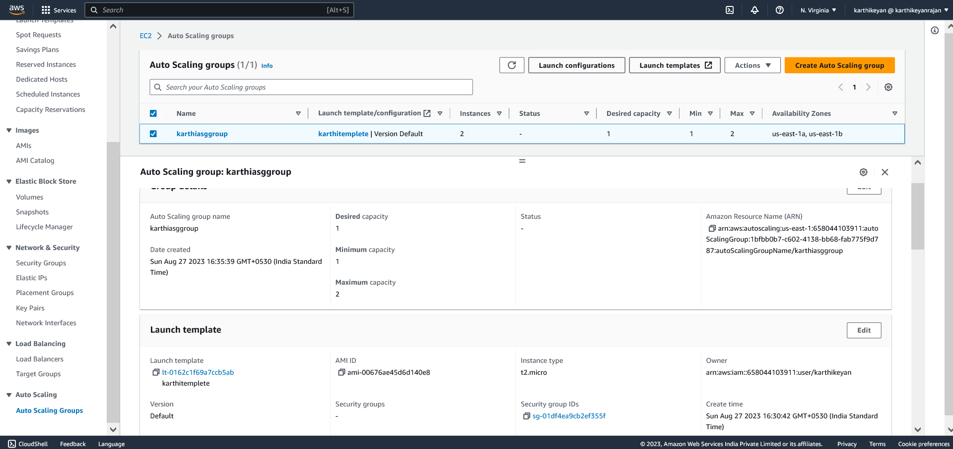

Min =1 Desired=1 maximum=2

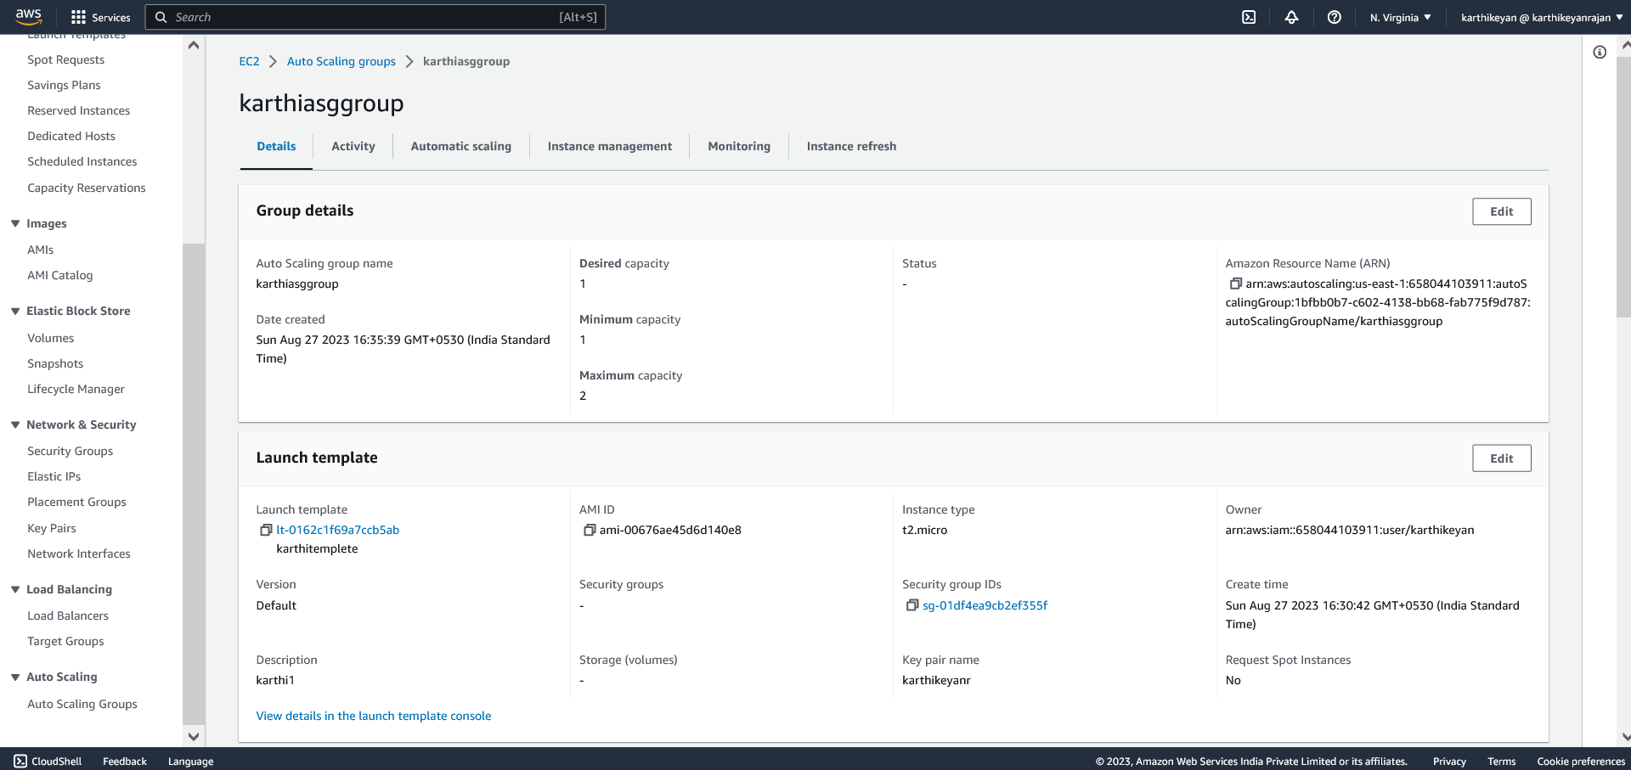

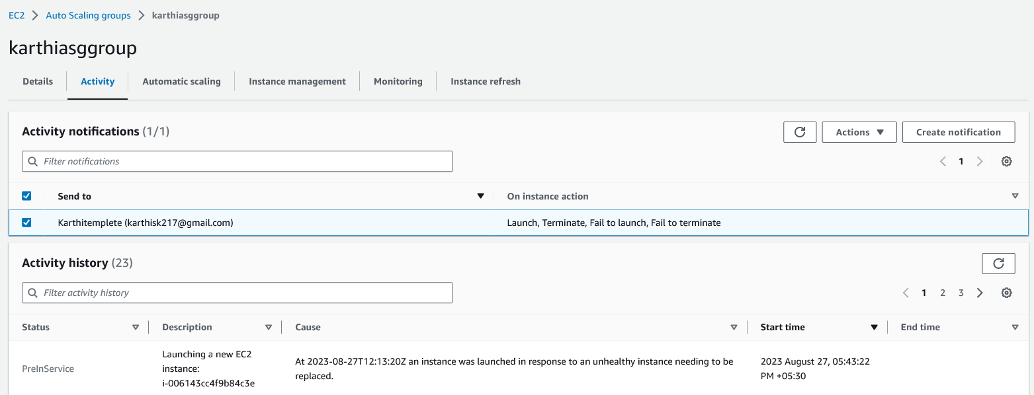

Master ans slave are the ec2 instance created by using terraform the unamed 2 instance that is created by ASG

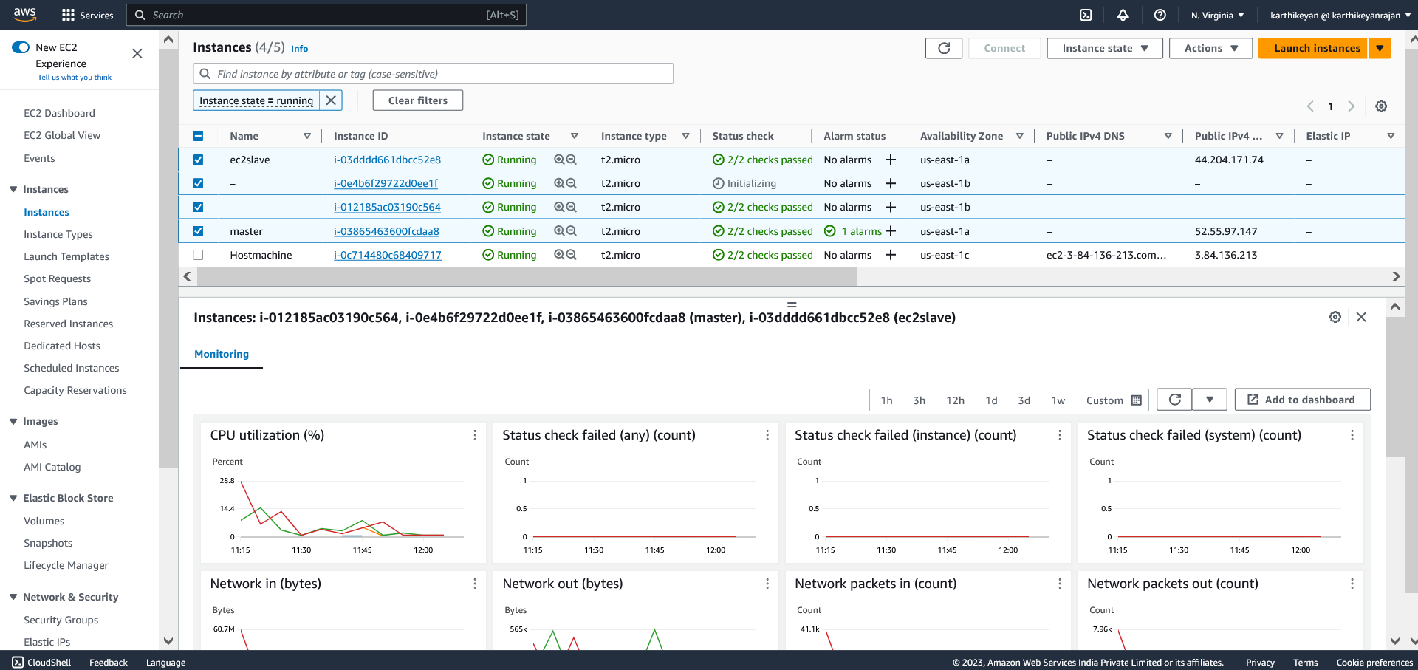

Getting cloudwatch alarm due to cpu load

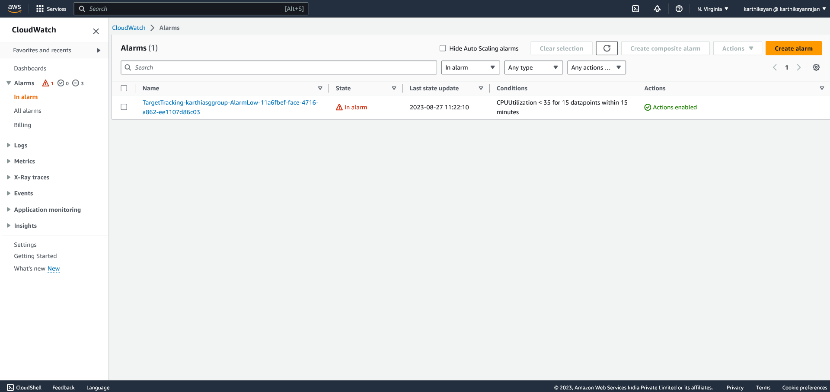

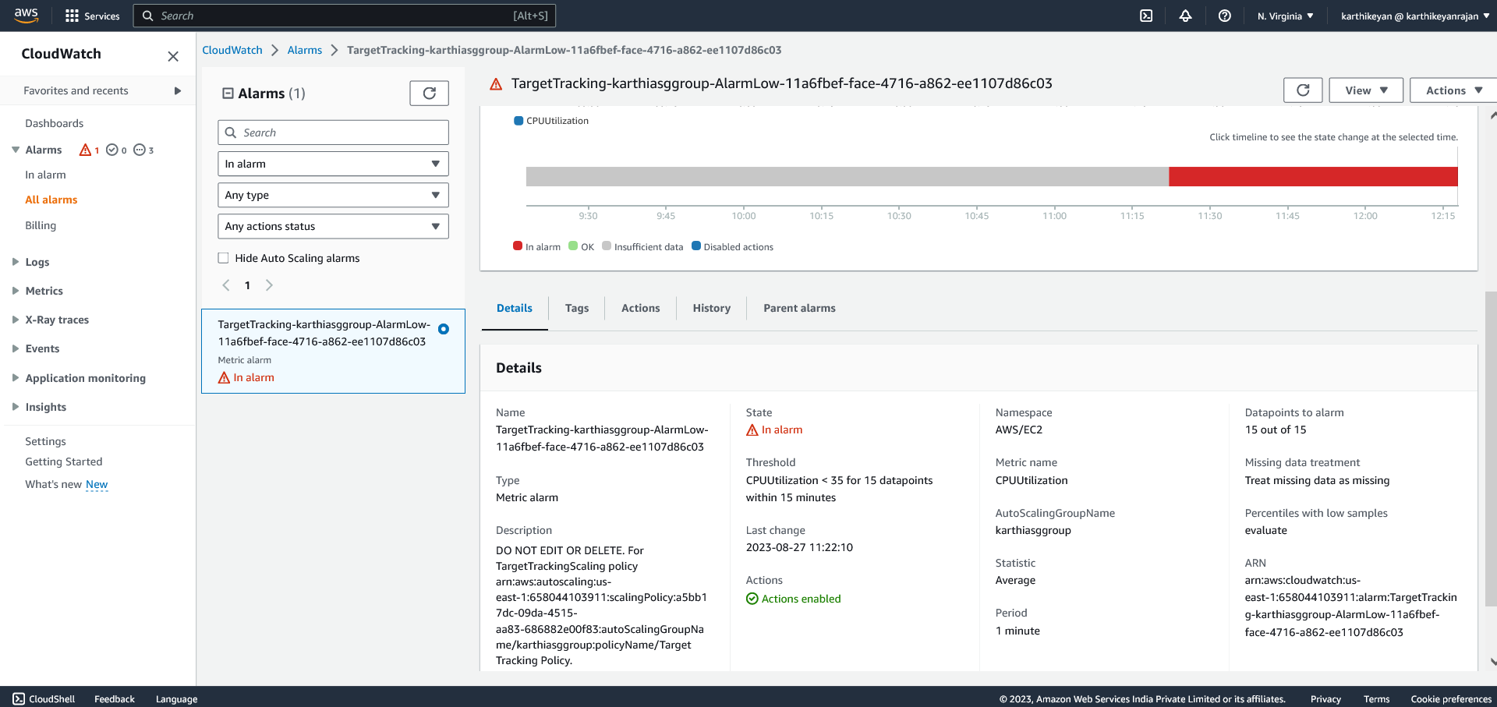

By using jenkins pipeline created the artifact and running the docker container with the shoestop page

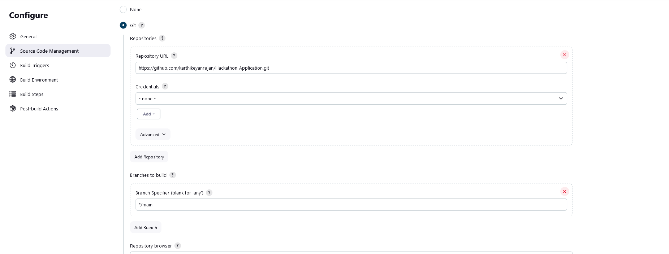

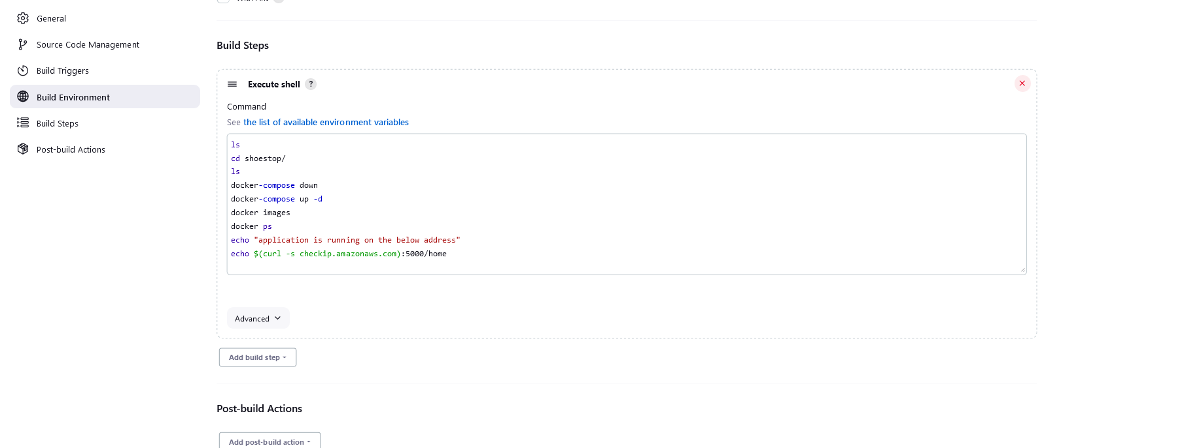

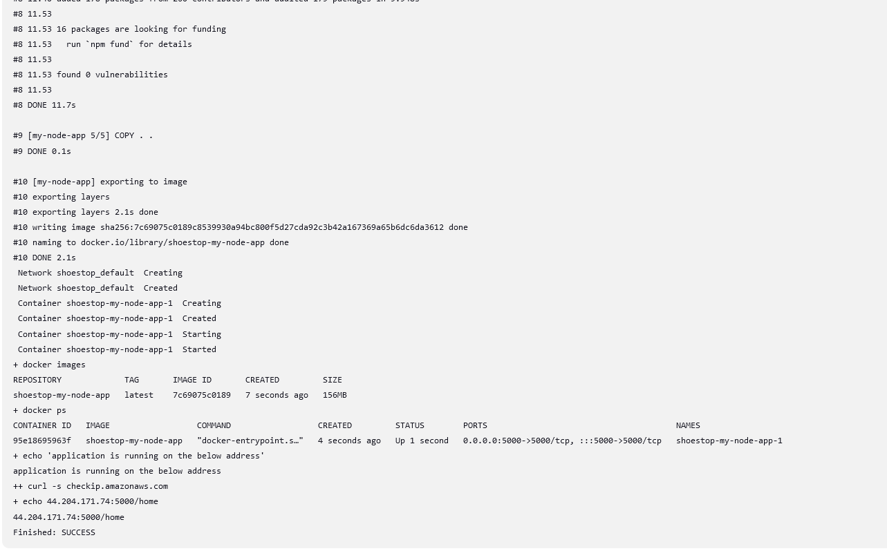

By using the ip able to view the output



Using the dns - DNS - karthilb-1867132382.us-east-1.elb.amazonaws.com

